1. Architectural Overview
The project is designed using a multi-tiered architecture that tightly integrates user interface presentation with relational data persistence. It utilizes Java Swing for the desktop frontend layer and JDBC (Java Database Connectivity) for the database layer, implementing an event-driven paradigm.
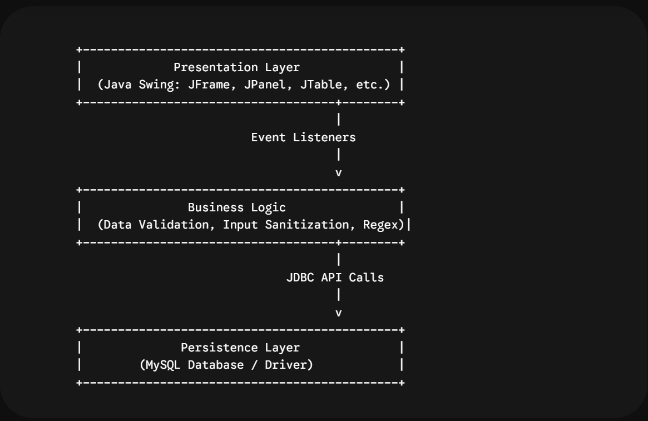
Component Roles
- Presentation Layer (javax.swing, java.awt): Renders the user-facing forms, functional operation panels, and relational tables. It captures user intent via Event Listeners (ActionListener, ListSelectionListener).
- Business Logic Layer: Handles frontend input sanitization, form validation using Regular Expressions (Regex), and dynamic state transitions (such as mapping selected table rows back into input fields).
- Data Access Layer (JDBC): Manages dynamic structural provisioning (database/table initialization) and processes transaction requests via parameterized query routines.
2. Database Schema & Data Persistence
The backend relies on an isolated relational model hosted inside a dedicated MySQL schema instance.
Schema Blueprint
- Database: student_db
- Target Table: students
Entity-Relationship Attributes
Note: The Java codebase initializes a column length of VARCHAR(50) for the course field, while the standalone SQL script defines it as VARCHAR(100). For production uniformity, modifying the Java dynamic table string initialization to VARCHAR(100) ensures schema alignment.
Column Name | Data Type | Key Constraints | Attributes | Functional Intent
student_id | INT | PRIMARY KEY | AUTO_INCREMENT | Unique internal system sequence identifier.
roll_no | VARCHAR(50) | UNIQUE | NOT NULL | External institutional academic identifier.
first_name | VARCHAR(50) | - | NOT NULL | Student given name.
last_name | VARCHAR(50) | - | NOT NULL | Student family surname.
email | VARCHAR(100) | - | Nullable | Primary contact email address.
phone | VARCHAR(20) | - | Nullable | Primary contact telephone number.
course | VARCHAR(100) | - | Nullable | Registered academic program.
enrollment_date | DATE | - | Nullable | Date of record generation.

Note: The Java codebase initializes a column length of VARCHAR(50) for the course field, while the standalone SQL script defines it as VARCHAR(100). For production uniformity, modifying the Java dynamic table string initialization to VARCHAR(100) ensures schema alignment.
3. Graphical User Interface (GUI) Layout Mapping
The structural interface maps its atomic elements across a nested BorderLayout container structure inside a unified desktop window (JFrame).
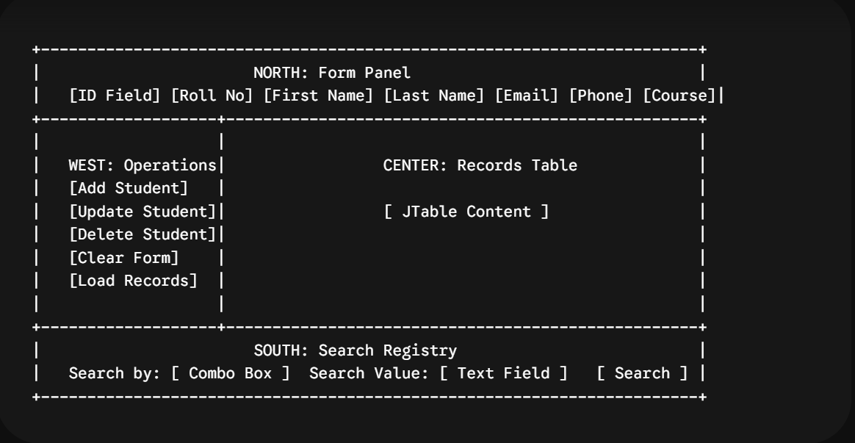
Visual Layout Breakdown
- North Region (GridBagLayout): Hosts the Student Information Form. Uses explicit structural anchoring constraints (GridBagConstraints) to align input components inside a multi-column modular grid.
- West Region (GridLayout(5, 1, 10, 10)): Houses the Operations Panel. Arranges uniform control buttons in a rigid vertical stack with 10-pixel proportional padding barriers.
- Center Region (BorderLayout): Houses the Student Records Panel. Embeds a structured JTable component inside a scroll wrapper (JScrollPane) to handle dynamic view extensions when records overflow the display area.
- South Region (FlowLayout(FlowLayout.LEFT, 10, 10)): Contains the Search Registry Panel, left-aligning query selector dropdown elements and search parameter text fields.
4. Key Programmatic Subsystems & Logic
Connection Management
To prevent connection leaks, the system relies on an execution pattern across its operations:
try {
connection = getConnection();// Execute query statement
} catch (SQLException e) {// Process error exceptions
} finally {
closeConnection();
}

This routine ensures that database connection resources are released immediately after a transaction finishes, regardless of whether the query succeeds or throws an exception.
Validation Pipelines
Data integrity is verified on the client side before any query assembly begins.
- Null Boundaries: Blocks empty strings for crucial data points (roll_no, first_name, last_name).
- Email Sanitization Pattern: Uses compilation regex validation: ^[A-Za-z0-9+_.-]+@(.+)$
- Phone Constraint Pattern: Verified using structural string lookups: phone.matches("\\d{10,15}") (Enforces 10 to 15 numeric digits).
Prepared Statements vs SQL Injection
The system uses PreparedStatement structures instead of raw string concatenation for CRUD executions:
String sql = "INSERT INTO students (roll_no, first_name, ...) VALUES (?, ?, ...)";
PreparedStatement statement = connection.prepareStatement(sql);
statement.setString(1, rollNoField.getText().trim());

This separation of SQL logic from parameter data prevents SQL injection vulnerabilities by ensuring the database engine treats input data strictly as literal values rather than executable code code.
5. System Workflow Analysis
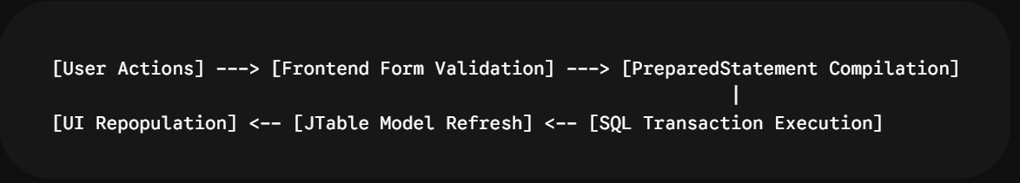
- Form Input & Validation: The user populates the form fields and triggers an operation button (e.g., Add Student). The validateForm() method checks the data format.
- Database Connection & Query Compilation: A connection is drawn via getConnection(). The system compiles a parameterized SQL statement and maps the sanitized inputs to their corresponding indices.
- SQL Transaction Execution: The query is committed to the MySQL server. If a violation occurs (such as a duplicate roll_no), an explicit catch block intercepts the error and alerts the user through a JOptionPane alert.
- UI Model Refresh: After a successful execution, the system triggers loadAllStudents(). This clears the existing UI rows via tableModel.setRowCount(0) and loops through a fresh data cursor (ResultSet) to rebuild the display table.
6. Recommendations for Production Optimization
While the current architecture is fully operational for an industrial prototype, implementing the following enhancements will improve system reliability, modularity, and security:
- Implement the DAO Design Pattern: Abstract the SQL query logic out of the Swing components into an independent Data Access Object (DAO) tier. This decouples user interface code from data storage logic, improving overall maintainability.
- Externalize Configuration Metadata: Move hardcoded infrastructure strings (Database URL, username, and system password credentials) out of the class file and into an external configuration file (e.g., an encrypted .properties or YAML file).
- Introduce Database Connection Pooling: Replacing direct individual connection instantiation cycles with a specialized connection manager framework (such as HikariCP or Apache DBCP) eliminates the overhead of opening and closing database connections for every CRUD transaction.
- Enhance Resource Auto-Closure: Update the JDBC statement handling to use Java's Try-With-Resources blocks. This ensures that database statements, connection interfaces, and data row pointers (ResultSet) close automatically in the correct order, simplifying error cleanup.
To provide a highly professional, presentable representation for the analysis report, two clear visual schematics have been structured below: a System Architecture Diagram (showing how components interact) and an Operational Flowchart (tracking a user request from input to database modification).
1. Three-Tier System Architecture Diagram
This diagram represents how the Java Swing presentation layer communicates with the underlying MySQL database through the validation and JDBC drivers.
+-----------------------------------------------------------------------------------+
| PRESENTATION LAYER |
| (Java Swing UI Form) |
| +----------------------------------------------------------------------------+ |
| | StudentManagementSystem (JFrame) | |
| | - formPanel (GridBagLayout)- buttonPanel (GridLayout) | |
| | - tablePanel (JTable Records) - searchPanel (FlowLayout) | |
| +-------------------------------------+-------------------------------------+ |
+-----------------------------------------|-----------------------------------------+
|
User Triggers Event Action
v
+-----------------------------------------------------------------------------------------+
| BUSINESS LOGIC LAYER |
| (Data Sanitization & Input Checks) |
| +---------------------------------------------------------------------------------+ |
| | validateForm() | |
| | - Required Fields Scan (Checks for null values / empty strings) | |
| | - Email Validation Pattern Verification (Regex Lookups) | |
| | - Phone Digit Pattern Boundary Controls (Length Enforcements)| |
| +-------------------------------------+---------------------------------------------+ |
+-----------------------------------------|---------------------------------------------+ |
|
Data Verified Successfully
v
+---------------------------------------------------------------------------------------------------+
| DATA PERSISTENCE LAYER |
| (JDBC & Relational Database) |
| +--------------------------------------------------------------------------------+ |
| | getConnection() -> PreparedStatement -> mysql-connector-java Driver | |
| +----------------------------------------------+----------------------------------------------+ |
| | |
| v |
| +----------------------------------------------------------------------------------------------+ |
| | MySQL Server Engine (student_db Schema) | |
| | - Primary Entity Table: 'students' | |
| +---------------------------------------------------------------------------------------------+ |
+----------------------------------------------------------------------------------------------------+

Visual Conceptual Reference
The schematic architecture diagram below visualizes the data flow pathways and layer isolation mappings within the system framework:
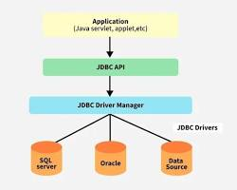
Student Information Management System architecture diagram flowchart swing jdbc.
